# Experiment Setup and Procedure

Document version: 1.0 8/25/2022

## Setting Up the VR Equipment:

### Base Stations:

* Make sure the 2 base stations are plugged in, and their lights are green.
* Position the tripods so that they are at the 2 corners of then room in front of the participant.
* The base stations should be placed as high up as possible, and angled downward at about 45-degrees, pointing at the participant.

### VR Headset:

* Plug the headset cable into the junction box, and plug the box into the USB and USB-C ports on the laptop, and the power cable to an outlet.
* Press the blue button on the junction box. You should see a green light on the box, and a red light on the left side of the headset.

### VR Room Setup

* 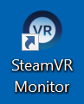Start up and log into the laptop, use your KUID.
* Open the Steam VR Monitor App, should be on the desktop.
* *NOTE: You may see a warning about “SteamVR needs to set itself up for App Containers”. Just dismiss and ignore.*
* 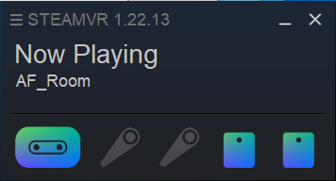Click the 3-bar menu in the top left corner of the STEAMVR window and choose **Room Setup**.
* When the calibration wizard starts, choose **Standing Only**. Follow the instructions on screen to calibrate and orient the headset.
* Look through the goggles, you should see the SteamVR start room correctly oriented.
* You should only need to recalibrate if you move locations, or move the base stations.
* *NOTE: When the VR system is running, the laptop fans will run constantly, this is normal.*

### Audio Settings:

The system volume keys will control the volume level for both the headset and the laptop speakers. Make the following settings to ensure that audio is coming from both the computer speakers, and the headset speakers.

* Click the 3-bar menu in the top left corner of the STEAMVR window and choose **Settings**.
* Select **Audio** from the left hand list.
* Ensure **Audio Output Device** is set to **VIVE PRO (NVIDIA HIGH DEFINITION AUDIO)**
* Ensure **Audio Mirroring** is turned **On**
* Choose **SPEAKERS (REALTEK(R) AUDIO)** from the drop down.
* Set Control mirror volume separately to **OFF**

These setting should stay once you set them, but just in case, these are the needed values.

## Running the App:

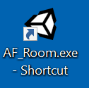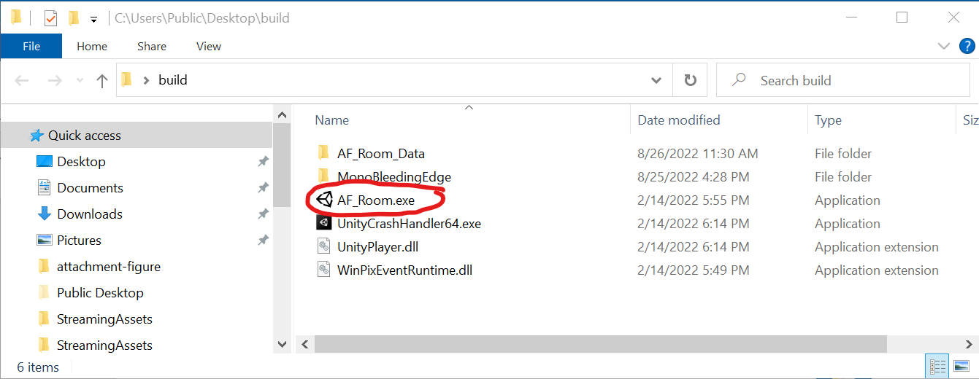A shortcut for the app has been added to your desktop. You can also find the app in the **build** folder on your user’s desktop. Look for the AF_Room.exe app.

Think of each time you run the app as a session. When you want to make a new session, or if something goes wrong and you need to start over, quit the app and open it again.

## Session Setup:

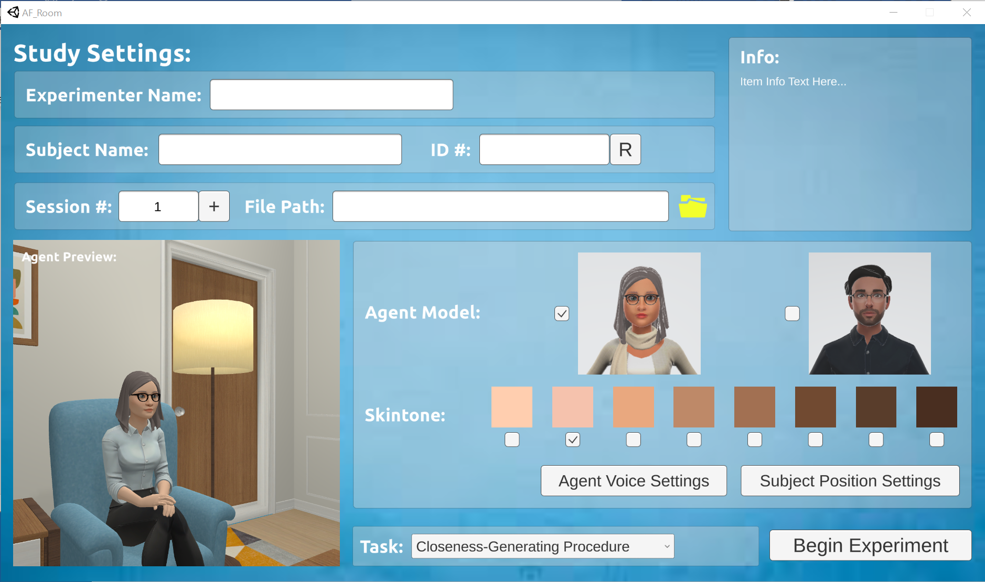

When the app starts up, you will see the Study Settings screen. Use this to fill in info about the current session. You can get help for each of the features by hovering your mouse over the input area and looking at the Info box in the upper right corner.

### Some important notes:

* You MUST enter an Experimenter Name, Subject Name, File Path, and ID number in order to start the experiment. If one of these items is missing the system will highlight the missing data.
* ID # can be any text or number you like.
* Session must be a number.

### File path:

This indicates where the results data for this session will be stored. Click the folder button to bring up a file browser. A data save folder called data is already provided for you on your desktop.

*C:\Users\Public\Desktop\data*

### Starting the Experiment:

When you are ready to start the experiment, click the **Begin Experiment** button in the bottom right corner of the interface.

* If there is data missing in the settings, the system will alert you.
* If there is already data in the save location for the subject, ID, and session number the system will alert you, and ask if you wish to overwrite the data.

## Session Interface:

When the session begins, you will be presented with a new interface. At this point, the session has begun, and data is being collected.

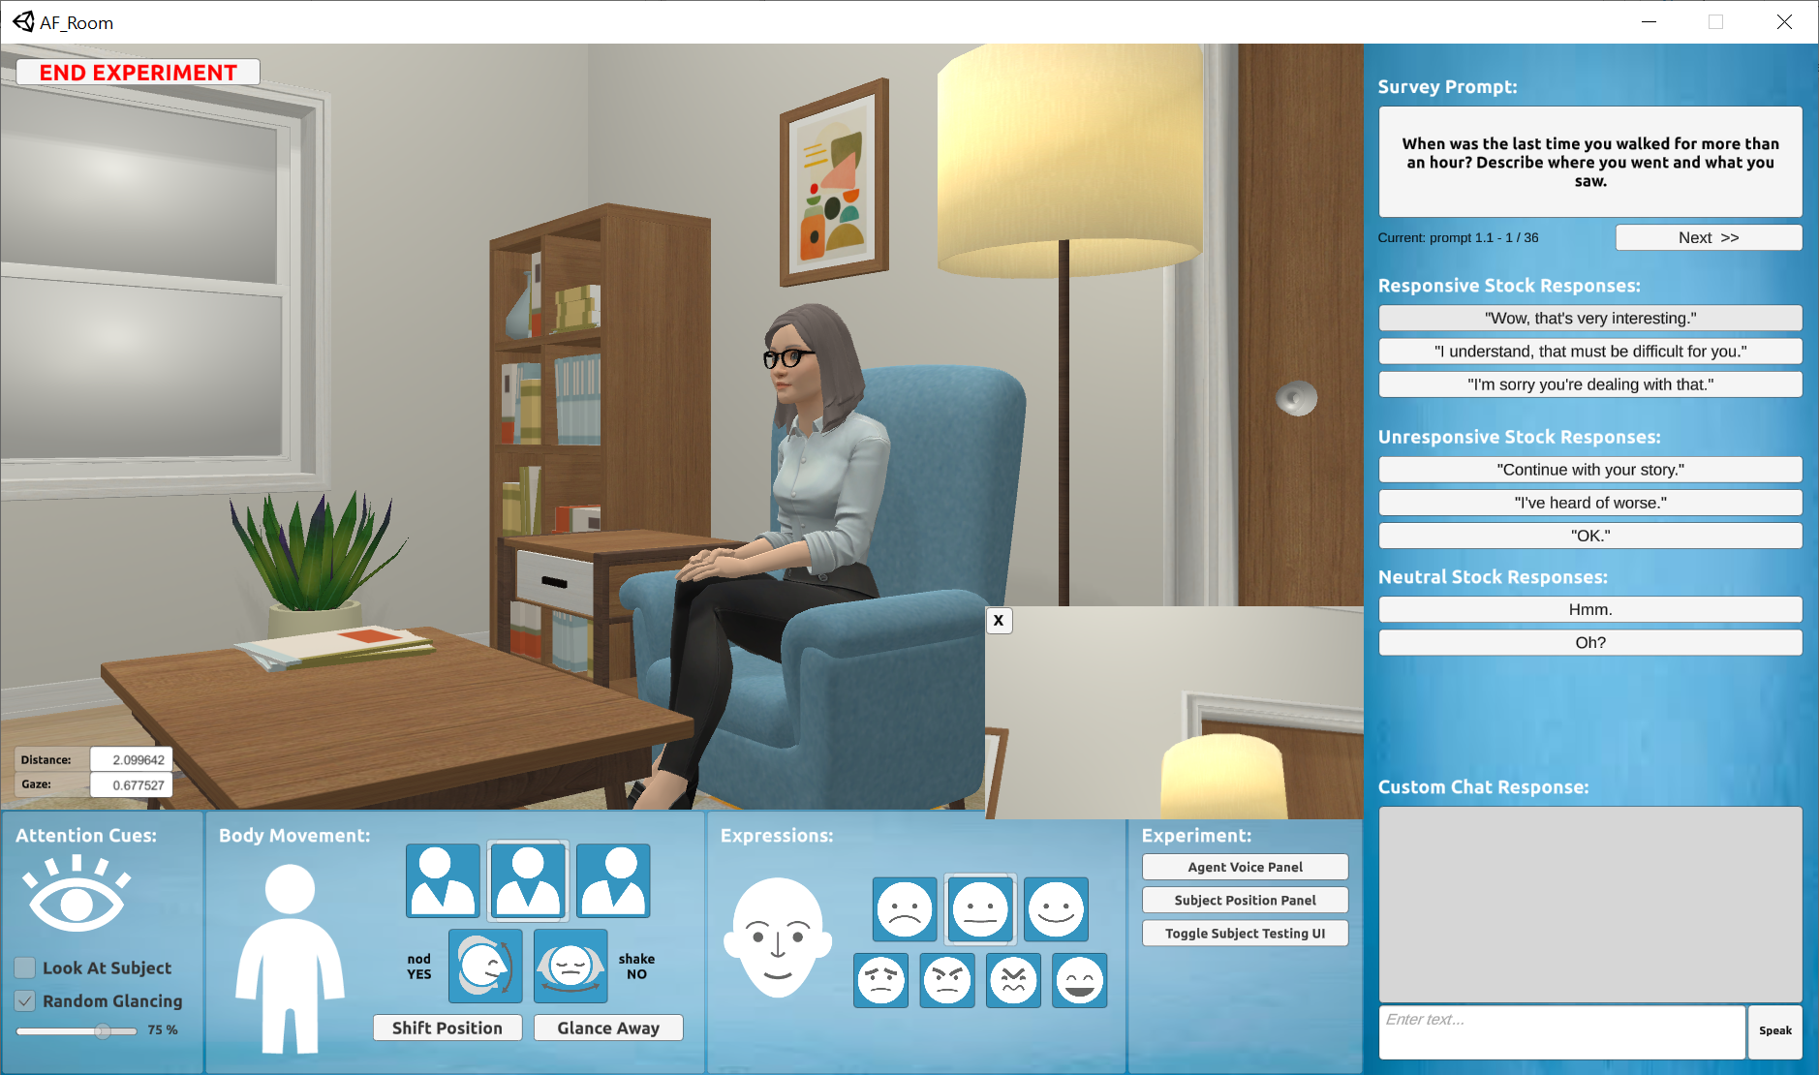

### Moving Through the Task Questions:

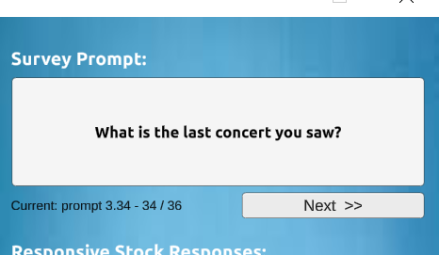The current task prompt question will appear on the large button in the top right corner. You can press this button any time, and as much as you like, to have the agent speak the question out loud.

Below the prompt is a counter telling you which set (here set 3) and prompt number (here number 34) you are on, and your progress through the set of questions (question 34 of 36 total).

When the subject is finished responding, press the **Next** button to move to the next question. This will stop collecting data on the first prompt and start collecting for the next prompt.

**IMPORTANT:** there is no way to return to a question once you have hit Next, so make sure you are finished with the current question.

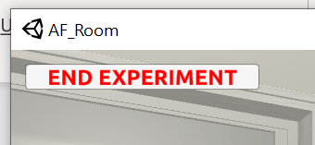

### Ending the Experiment:

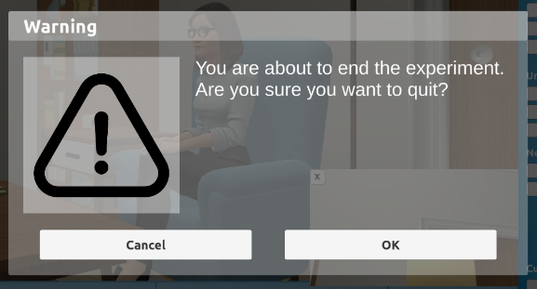When you reach the final question of the question set, or if you wish to end the session early without completing all questions, press the large red **End Experiment** button in the top left corner. The system will prompt to make sure you really want to quit.

When you choose OK, the final statistical calculations will be performed and the results will be written out to the results files.

IMPORTANT: When the session is done, make sure to use the **End Experiment** button and NOT the [X] close button in the top of the window. The [X] button will cause the program to end abruptly, and some data may not be written out to the result file.

## Task Questions:

The app will take question sets from the following 2 files:

*build/AF_Room_Data/StreamingAssets/****Closeness-Generating Procedure.csv*** *build/AF_Room_Data/StreamingAssets/****Small-Talk Condition.csv***

You can edit these files to adjust the wording of questions, add or remove questions, etc. Make sure to follow the format of the current files, and make sure not to change the names of the headings for each column within the files. The columns are as follows:

* **Block_num** – should always be 1
* **Prompt Set** – use this number to create sub groups within your larger set of questions. This number will appear in the interface on the question counter, and be transcribed to a column in the results file.
* **Prompt Number** – A number for each prompt. These can be any number you like, and do not need to be in order or unique, but probably should be both. They will be displayed on the question counter in the interface, and transcribed to the results file.

## Experimental Data:

Within the data folder you will find the following structure:

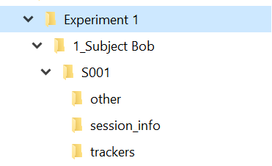*Experiment 1/  
----<ID>_<Subject Name>/  
--------<Session Number>/  
------------other/  
----------------* ***EventLog.csv*** *------------session_info/  
----------------* ***log.csv*** *------------trackers/  
----------------* ***subject_average proxemics_T001.csv*** *----------------* ***subject_proxemics_T001.csv*** *------------****trial_results.csv***

### File Contents:

### log.csv

Log file containing debug and error message information from the application. If the program crashes or something goes wrong, this file can help figure out what caused the crash.

### EventLog.csv

A log of major events during the session. This is basically provides time stamps for each thing the agent says (speech events) or does (animation events), all triggered by the experimenter.

* Time - Time of the event, measured as seconds from the start of the session.
* System time - Time of the event, in system time.
* Event type - The type of event – stock speech, custom speech, animation, etc.
* Message - The message that was spoken, if applicable.

### subject_proxemics_TXXX.csv

The raw proxemics sample data from the trial. Data is collected approx. every 0.3 seconds. The columns are as follows:

* **time** – time since the start of the session, in seconds.
* **system time** – system time when sample was taken.
* **distance** – distance between the subject headset and the agent’s head, measured in virtual meters.
* **gaze** – gaze score in the range of [0,1] where 0 is looking away, and 1 is looking directly at the agent.

### subject_average proxemics_TXXX.csv

Running averages of the same raw data above, taken every 60 seconds.

### trial_results.csv

This is the main results file for the session. The session is divided into a number of trials, where each trial is one of the response questions from the questions set. Each row of the results file represents data collected for that particular question (trial). Data columns are as follows:

* **experiment** – name of the experiment. Will be the same for each row.
* **ppid** - <subject ID>_<subject name>. Same for each row.
* **session_number** – the session number entered at the start of the session. Same for each row.
* **trial_num** – cooresponds to the number of the question from the question list.
* **block_num** – currently not used, will always be 1.
* **trial_num_in_block** – currently not used, will be the same as trial_num above.
* **start_time** – time this trial started, measured in seconds since the start of the session.
* **end_time** – time this trial ended, measured in seconds since the start of the session.
* **Experimenter Name** – as entered in the start screen. Will be the same for each row.
* **Subject Name** – as entered on the start screen. Will be the same for each row.
* **Subject ID** – as entered on the start screen. Will be the same for each row.
* **Session** – session number as entered on the start screen. Will be the same for each row.
* **File Path** – path to this data folder. Will be the same for each row.
* **Voice Name** – the Text-To-Speech voice used for this session.
* **Voice Pitch** – pitch value for this voice, defaults to 1.
* **Voice Volume** – the volume level for the voice, defaults to 1.
* **Voice Speed** – the speed of speech generated, defaults to 1.
* **Model** – the model selected for the agent. The female model is 0, the male model is 1. Will be the same for each row.
* **Skintone** – the skintone selected for the model. Default is 1. Will be the same for each row.
* **Task** – the task set selected on the start screen - Closeness-Generating Procedure or Small-Talk Condition. Will be the same for each row.
* **Prompt Set** – the set the current prompt was drawn from within the task. Drawn from the task setup file.
* **Prompt** – the text of the prompt.
* **trial average distance** – average of distance samples for just this trial.
* **trial median distance** – median of distance samples for just this trial.
* **trial standard deviation distance** – standard deviation of samples for just this trial.
* **trial average gaze** – average of gaze samples for just this trial.
* **trial median gaze** – median of gaze samples for just this trial.
* **trial standard gaze distance** – gaze deviation of samples for just this trial.
* **global average distance** – average of distance samples over the whole session. Will be the same for each row.
* **global median distance** – median of distance samples over the whole session. Will be the same for each row.
* **global standard deviation distance** – standard deviation of samples over the whole session. Will be the same for each row.
* **global average gaze** – average of gaze samples over the whole session. Will be the same for each row.
* **global median gaze** – median of gaze samples over the whole session. Will be the same for each row.
* **global standard gaze distance** – gaze deviation over the whole session. Will be the same for each row.
* **subject_average proxemics_location_0** – file path to 60-sec interval average data.
* **subject_proxemics_location_0** – file path to raw sample data.

## Closing Down the VR Equipment:

**IMPORTANT:** unplug the 2 base stations if you are not going to be using the equipment for a while (more than an hour or so). These contain small spinning motors that will wear out over time.

The other items can be safely left plugged in.

Shut down or put the laptop to sleep.